# Abstract

Cellular Automata (CA) models are widely adopted to reflect real-world urban dynamics, but many studies oversimplified the spatial complexity of driving factors. The advancement of deep learning (DL) technology enables spatial patterns of different levels to be assimilated, thus addressing urban development's spatial complexity. In this study, we selected UNET to retrieve transition rules in urban simulation automatically, described the process of spatial pattern extraction, and applied the learned model to 76 cities in the North China Plain. The results show that 1) the UNET model identified high-level spatial patterns and refined these patterns to detailed shapes, 2) the FoM (Figure of Merit) of the simulation map is close to conventional studies that went through a length calibration process, and 3) the landscape pattern between the simulation and the reference map is well aligned. UNET learned inherent urban development patterns, which can supplement conventional CA models to integrate spatial features to project future urban development.

# 1. Introduction

Urbanization is one of the most important anthropogenic activities (Qiu et al. 2020; Chu et al. 2017; Kalnay and Cai 2003). Correctly projecting the future urban layout enables efficient resource management (Lin et al. 2021) and waste neutralizing (Yue et al. 2020), and prompts sustainable urban development (Wang et al. 2021b). Urbanization is modeled with two major objectives: the prediction models aim at creating future urban maps based on historical urban dynamics (Gantumur et al. 2020; Shafizadeh-Moghadam et al. 2017), and the participatory models focus on projecting stakeholders’ impacts to balance conflicting interests (Clarke and Johnson 2020; Mansour et al. 2020; Peng et al. 2020). The nuances between the prediction and participatory models lead to a diverging focus on parameter setups: the former takes regression tools or machine learning (ML) algorithms to create accurate projections for urban planning and decision-making; the latter ingest stakeholders’ interests and are calibrated with expert knowledge to inform the understanding for the urbanization mechanism. The Cellular Automata (CA) has been widely adopted in both models because of its mathematical resemblances to the real-world urban dynamics (Tong and Feng 2020; Li et al. 2017). CA models are primarily built on transition rules and neighborhood status, which were combined to convert driving factors and their interactions to the probability of a cell to be urbanized in the future (Roodposhti et al. 2020; Wang et al. 2021a). The transition rules were retrieved using logistic regression (Mustafa et al. 2018), uncertainty quantifications (Mansour et al. 2020), neuron networks (Gantumur et al. 2020), heuristic methods (Carneiro and Oliveira 2013), or decay functions proposed by experts. The neighborhood status was identified according to different structures, sizes, and weights. Although CA models are flexible with a large array of combinations given various transition rules and neighborhood status, the sophisticated urbanization process still poses challenges to urban modeling.

Urbanization is a complex process associated with social, cultural, economic, geographical, and political factors (Tzaninis et al. 2021). This process follows some universal rules as urban development must conform to physical constraints that regulate human exploitation on lands, meanwhile, stochasticity also drives urban development because to build or not depends on the specific local conditions. The first law of geography abstracts such universal rules as geographical correlations: “everything is related to everything else, but near things are more related to each other” (Tobler 1970). The second law of geography describes the local stochasticity as “geographic variables exhibit uncontrolled variance” (Goodchild 2004). These two laws were combined to form the foundation of CA models. For example, some CA models assign the central pixel with a higher weight than surround cells upon creating transition rules to mimic the first geography law (Clarke and Johnson 2020; Prayitno 2020). Many studies incorporate the shape index and texture information to reflect the second law of geography (Zhai et al. 2020; Ruiz Hernandez and Shi 2018). Some studies tried to balance these two laws by subsetting the study area into separate zones, allowing independent transition rule sets to be constructed to align with the unique condition in each zone (Qian et al. 2020; Xia and Zhang 2021). Despite having successfully constructed transition rules within the neighborhood scope, these studies presented mismatches comparing to real-world urbanization: 1) prediction models oversimplified the spatial heterogeneity of driving factors, and 2) participatory models introduced subjectivities upon constructing the transition rules and determined neighborhood status. Distances and spatial configurations of geographical factors are key to urban development in the real world. However, the participatory models measure the impacts of these factors with decay functions developed by experts, and subjectivities are inevitably raised given the gap between human knowledge and real-world urban dynamics. The prediction models, although retrieve the transition rules automatically to avoid subjectivity, underestimate the spatial heterogeneity of the urbanization process: the complex spatial configuration within a neighborhood is represented by a single shape index, which hardly captures the pattern information of geographical drivers. A shared problem of prediction and participatory models is overlooking the large-scale features of driving factors. The optimum neighborhood sizes of these models were usually small (< 20), but the large-scale configurations, e.g, the shape of the built city, influence the urban development as well. Therefore, the advances for existing urban simulation models should be 1) capturing the large-scale spatial heterogeneity of driving factors, and 2) assimilating geographical variables automatically to reduce subjectivity.

The advanced Deep Learning (DL) technology enables the spatial configurations, rather than proxied variables like decay distances, of driving factors to be integrated into urban development simulation. Hubel and Torsten N. Wiesel (1962) found that different cells in the cat’s cortex responding to different simple stimulations such as light, orientation, and movement, and the neuron system integrated these stimulations to produced high-level visuals. The Convolutional Neuron Network (CNN) is a computation mimic to such vision systems that extract and assimilate low-level spatial features into high-level patterns (Krizhevsky et al. 2017), and it has been introduced to CA models to simulate urban development. For example, Zhai et al. (2020) used CNN to extract the spatial features from driving factors within a neighborhood and improved the performances of urban development simulation. Qian et al. (2020) proposed a 3-D CNN model that coupled historical urban dynamics with CNN and found it outperformed conventional CA models. Although the spatial features introduced by CNN improved the simulation performance, the conventional CA models, built on regression or ML algorithms to create transition rules in a neighborhood scope, were incapable of processing these features into high-level patterns. Therefore, more advanced DL structures that fully take advantage of CNN’s pattern recognition ability, i.e., integrate low-level spatial features to high-level patterns, are required to simulate urban development.

We adopted the UNET to mimic the urbanization process in this study. UNET is a DL structure that was first introduced for biomedical image segmentation and the unique design allowing it to extract and assimilate spatial features at different levels (Ronneberger et al. 2015). The robust segmentation performance enables UNET to be used in multiple fields such as geography (Singh et al.), environmental engineering (Nezla et al.), remote sensing (Ji et al. 2019), etc. More variations of the UNET were developed to better suit different purposes. For example, pixel-wise regression using UNET was applied to sharpen images (Yao et al. 2018), 3-D UNET was proposed to segment volumetric images (Çiçek et al. 2016), and TernausNet linked existing DL structure to improve the segmentation performance (Iglovikov and Shvets 2018). We used the basic UNET structure in this study because it is simple and efficient enough for urban dynamic pattern recognition. Down-sampling layers, up-sampling layers, and skip-connections are the primary components for UNET. The down-sampling layer enables UNET to extract the general contexts from the input data. The up-sampling layers refined these contexts to precise shapes. The skip-connections balance the generalization of down-sampling and the refinement of up-sampling (Ronneberger et al. 2015). Unlike CA models that have a definite neighborhood size, the UNET, in essence, deploys a series of moving windows of 3 × 3, 7 × 7, …, 65 × 65 (this study) to extract large scope spatial features gradually and then assimilate these features automatically to produce transition rules. The intuition of using UNET is that shapes matter in the real world: given the same distance to existing urban areas, the one near road crosses is more likely to be urbanized than the one near a straight road section. We hypothesis that UNET supplements the conventional urban simulations with two advancements: 1) identify and assimilate large scope spatial patterns that drive urban development, and 2) reduce the subjectivity upon calibrating the simulation models.

This study aims at mimicking and projecting urban development using advanced DL architecture. Conventional CA models cannot fully ingest spatial features, which are, however, key to the urbanization process in the real world. We used the UNET to integrate large-scale spatial configurations for urban development simulation in the North China Plain. The primary objectives are: 1) visualizing and investigating the high-level features identified by the UNET model, and 2) validating the simulation and projecting the urban map to 2030. We discussed the advantages of the UNET and its promising prospect to supplement conventional CA-based urban simulations. Local and regional sustainable development could benefit from improved urban dynamic simulations using advanced DL technology.

# 2. Methods

The research workflow is summarized in Figure 1. The Landsat archive was used to map the urban development from 1990 to 2019 with a 3-year interval (Wang et al. 2021b). Digital Elevation Model (DEM) and slope were used to improve the projection performance. All raster data had the same 30m resolution and were concatenated together to increase processing efficiency. The training samples were randomly cropped from the training image (i.e., the concatenated image with an urban map of early date) with the size of 256 × 256 pixels. The UNET was trained on these samples and then applied to the base image (i.e., the concatenated image with an urban map of late date) to produce the transition potential map. Then a threshold was determined to binarize the transition potential map into a hard classified map. The pixels with the value 1 in the hard classified map were allocated as the urban land and 0 as non-urban land. Lastly, we evaluated the performance of the transition potential map using the receiver operating characteristic (ROC) and assessed the hard classified map using map-overlay and landscape metrics.

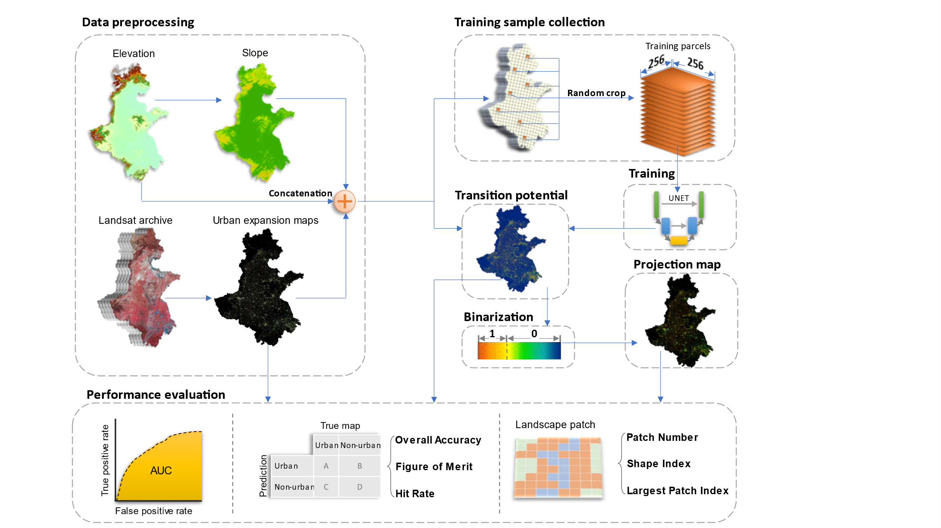

Figure 1. The research workflow

## 2.1 Study area

The study area (Figure 2) includes 76 cities, spans over 780,000 km2 area, and homes to over >450 million people (National Bureau of Statistics of China 2019b). This area is one of the fastest urbanized regions in China that have tripled the built-up land coverage rate from ~5% in 1990 to ~15% in 2020 (Wang et al. 2021b). This region is crucial to China's economic development and holds a strategic role to safeguard China's food security because over one-third of the national gross domestic product and grain supply was generated there (National Bureau of Statistics of China 2019a). The tension between urbanization and farmland conservation in the study area requires accurate and spatial-explicit understandings for future urban development to address the challenges of food security, environmental protection, and urbanization.



Figure 2. The study area. The map is modified according to the Figure 1 from Wang et al. (2021b).

## 2.2 Data preprocessing

The raster data used in this study were summarized in Table 1. The urban dynamics map (Figure 3) were obtained from Wang et al. (2021b). This product spanned from 1990 to 2019 with 3-year intervals and had a consistently high accuracy of > 94% across years. The use of temporal features successfully delineates urban land from fallow cropland, and a further consistent check removed unreasonable urban developments. The DEM was obtained from the Shuttle Radar Topography Mission (SRTM), and the slope data was derived from the DEM. The DEM and slope were used to assist the UNET to simulate urban development in different topology conditions, which have been proven effective in previous studies (Xing et al. 2020; Wang et al. 2021a; Qian et al. 2020).

Table 1. Raster data used for urban projection

|  |  |  |  |
| --- | --- | --- | --- |
| **Data Type** | **Source** | **Resolution** | **Time** |
| Urban dynamics | Wang et al. (2021b) | 30m | 1990-2019 |
| DEM | SRTM | 30m | 2000 |
| Slope | Derived from DEM | 30m | 2000 |

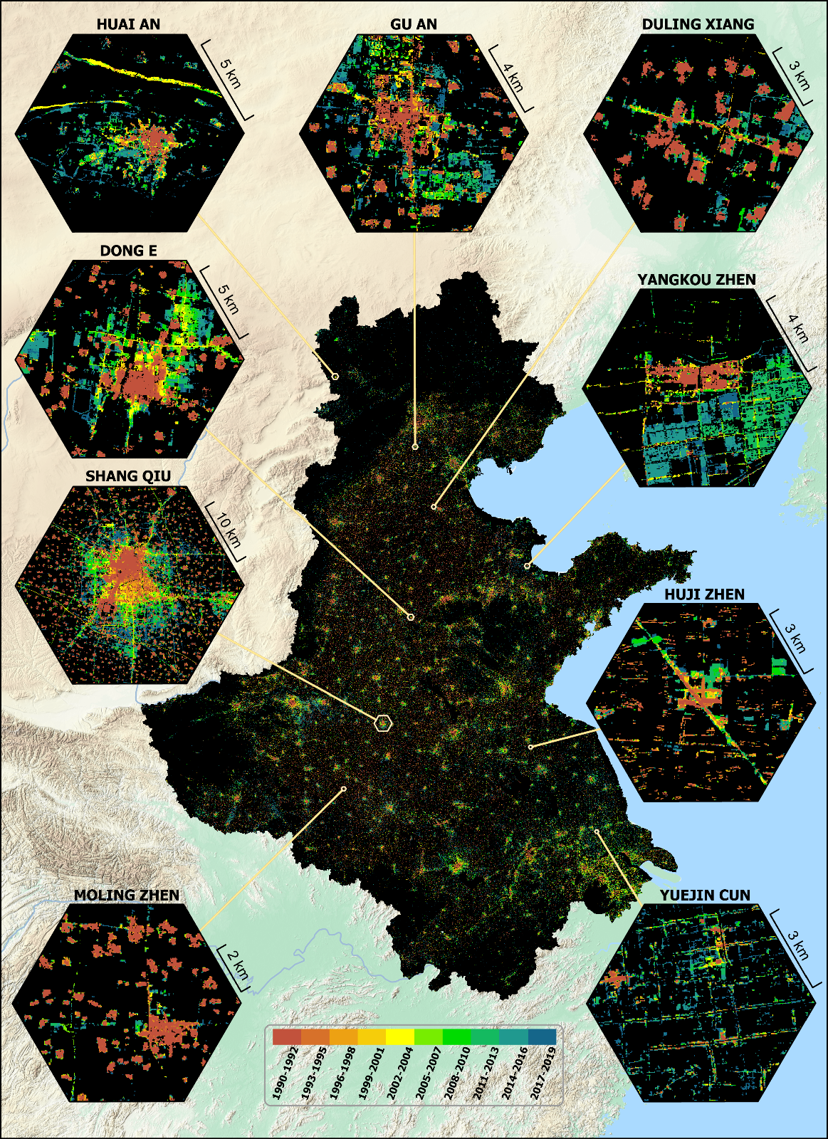

Figure 3. The urban dynamic map of the North China Plain.

## 2.3 Training the UNET

Control samples were collected at the Google Earth Engine platform for powerful cloud computation advantages (Gorelick et al. 2017). The *neighborhoodToArray* module was used to randomly crop tiled image samples from the training image. We set the neighborhood size to 256 following common data science practices (Ronneberger et al. 2015), and collected 20,000 samples for training and 5,000 for validation.

The UNET was trained on tiled images of 256 × 256 pixels (Figure 4). Each training image tile includes 3-layer input data (an urban map of early time, a DEM, and a slope map) and a single-layer target image (an urban map of late time). The 3-layer image tiles, during training, will be transformed to the size of 8 × 8 pixels after five down-sampling (i.e., max pooling with kernel size and stride of two) processes, and then converted to a single-layer output image that was the same size to the input image tile with another five up-sampling (i.e., transpose convolution with kernel size and stride to be two) operations. The mean squared error (MSE) was used to measure the difference between the output image and the target image. A total of > 31 million parameters were involved in the training process, and the derivative of each parameter to the MSE was computed via a backpropagation process. The parameters were updated according to their derivatives to the MSE using the Adam algorithm (the learning was 0.001, beta-1 to be 0.9, and beta-2 to be 0.99). We iterated the training process for 200 epochs (an epoch refers to the UNET updating its parameters using all 20,000 training samples) and computed the MSE on validation samples to determine the best model.



Figure 4. The design of the UNET.

## 2.4 Producing the simulation map

The base image was split into image tiles, supplied to the trained UNET to produce separate outputs, and then the outputs were mosaiced into a single transition potential map. The pixel values of this map ranged from 0 to 1, indicating the probability of being an urban pixel in the projection date. To reduce the "edge effect," the image tiles were cropped at the size of 320 × 320 pixels that supplied with a 32-pixel width buffer to be removed after being processed by the UNET (Figure 5). Although the UNET was trained on image tiles of 256 × 256 pixels, it works on image tiles of 320 × 320 pixels (Long et al. 2015).



Figure 5. Buffering image tile to reduce "edge effect."

The hard classified map was created by binarizing the transition potential map. We computed the pixel counts of the transition potential map at an interval of 0.0001 and accumulated these pixel counts descended. The binarizing threshold was determined to be the accumulation value that was the closest to the urban pixel count in the target year. The pixels greater than the binarizing threshold were allocated to value 1 to indicate simulated urban land; other pixels were allocated with 0 to indicate non-urban pixels. The binarisation was carried out independently at the city level to reduce the bias caused by different regional development levels.

## 2.5 Validate the simulation

Only the newly urbanized areas were validated to reduce the bias from vast persisting areas. The transition potential map was assessed using the area under the curve (AUC) of the ROC. The hard classified map was evaluated via map-overlay and landscape metrics (Tong and Feng 2020). The map-overlay metrics selected in this study were overall accuracy (OA), the Hit rate, and the figure of merit (FoM). The landscape metrics selected in this study were patch number (PN), landscape shape index (LSI), and the largest patch index (LPI). The equations and explanations for selected metrics were in Table 2. Given the vast research area, the validation was performed on each city of the research area independently; thus, a total of 76 results (the number of cities in the research area) were acquired for each metric.

Table 2. Validation metrics to evaluate the hard classified map

|  |  |  |
| --- | --- | --- |
| **Name** | **Equation** | **Explanation** |
| AUC | $$\int_{x=0}^{1}{TPR({FPR}^{-1}(x))dx}$$ | A measure of aggregated classifications reflects the model's sensitivity under different thresholds(Tong and Feng 2020). |
| OA | (A + D) / (A + B + C +D) | Measure a model's overall performance on both positive and negative predictions. |
| Hit rate | A / (A + C) | Measure a model's predictive performance on the true positive outputs. |
| FoM | A / (A + B + C) | Measure a model's performance on the true positive outputs from both the prediction and actual perspective(Pontius et al. 2008). |
| PN | *n* | Reflect the fragmentation of a given landscape. |
| LSI | $$\frac{\sum{p_{i}}}{4\sqrt{\sum{a_{i}}}}$$ | Reflect the complexity of a given landscape. For example, a squared patch is deemed simple (low value), whereas a linear patch is complex (high value). |
| LPI | $$\frac{max⁡(a_{i})}{\sum{a_{i}}}$$ | Reflect the dominance of the largest patch to the total landscape area. |

Note, TPR is the true positive rate, FPR is the false positive rate of the ROC from the transition potential map. A refers to correctly predicted urban pixels (hit), B refers to the incorrectly predicted urban pixels (false alarm), C is the incorrectly predicted non-urban pixels (miss), and D is the correctly predicted non-urban pixels (correct rejection). n is the total number of landscape patches. $p_{i}$ is the perimeter (m) of the *i*th path of the urban patches, $a_{i}$ is the area (hectare) of the *i*th patch of the urban patches.

We first validated the simulation performance of the UNET using historical urban maps, then trained another UNET model to project urban land to 2030. The urban maps of 1993-1995 and 2005-2007 were selected to train the validation UNET that produced a simulated urban map of 2017-2019, which was assessed by comparing it to the reference urban map. To project to 2030, we used the exponential regression to fit the historic urban areas and extrapolated them to 2030, then applied this extrapolation area to binarize the transition potential map created by the projection UNET trained on the urban maps of 2005-2007 and 2017-2019.

# 3. Result

## 3.1 Model training

The MSE of the UNET trained on the urban images of 1993-1995 and 2005-2007 is in Figure 6. The MSE was decreasing first and then increased continuously. The lowest MSE was ~0.022 at the 70th epoch, which was determined as the best model to produce the simulated urban map of 2017-2019.



Figure 6. The validation loss of the UNET at different epochs

A randomly picked image tile was used to reveal the UNET's processing on input data. The last activation map of each layer was used to visualize its pattern recognition capability (Figure 7). The down-1 layer had learned to distinguish urban and non-urban pixels. The down-2 layer had learned to recognize simple patterns: the horizontal and vertical roads were highlighted, and larger towns were pushed out among small villages. The down-3 layer had learned to associate adjacent urban clusters: potential urban development corridors were identified to connect discreet towns/villages. The down-4 layer had learned to allocate higher urban development probability to the pixels near existing towns/villages, making the urban development corridors more concentrated and intensive. The bottleneck layers identified the overview of the urban development in the target year. The up-layers were learned to disintegrate the high-level patterns in the former down-sampling layer: the up-4 layer refined the overview patterns in the bottleneck layer by combining the bottleneck layer and the down-4 layer; the up-3 layer further polished the spatial feature in the up-4 layer by assimilating the "urban development corridors" pattern identified in the down-3 layer. At last, the up-1 layer associated the urban/non-urban activation maps in the down-1 layer with the up-2 layer, producing the final output image tile, which allocated more urban pixels around bigger towns and maintained a refined pattern.

**Down-1**

**Down-2**

**Down-3**

**Down-4**

**Up-4**

**Up-3**

**Up-2**

**Up-1**



Urban extent

DEM

Slope



**Input image tile**

**Output image tile**



**Bottleneck**

Figure 7. The visualization of an image tile process by different layers in the UNET. Note that we only selected a few activation maps for visualization given the limited space.

## 3.2 Validation maps

The transition potential map was shown in Figure 8. The pixels near large towns and cities were allocated with higher transition potential value than small villages. For example, a large chunk of pixels surrounding Gu'An town were highlighted with high transition potential values, while only thin edges of nearby villages were identified as urban in the future. Similar patterns were shown in Shang'Qiu. The linear structures were well captured in the transition potential map. For example, the roads in Mo'Ling town and Yue'Jin village were identified despite only discreet roads segments shown in the original map.

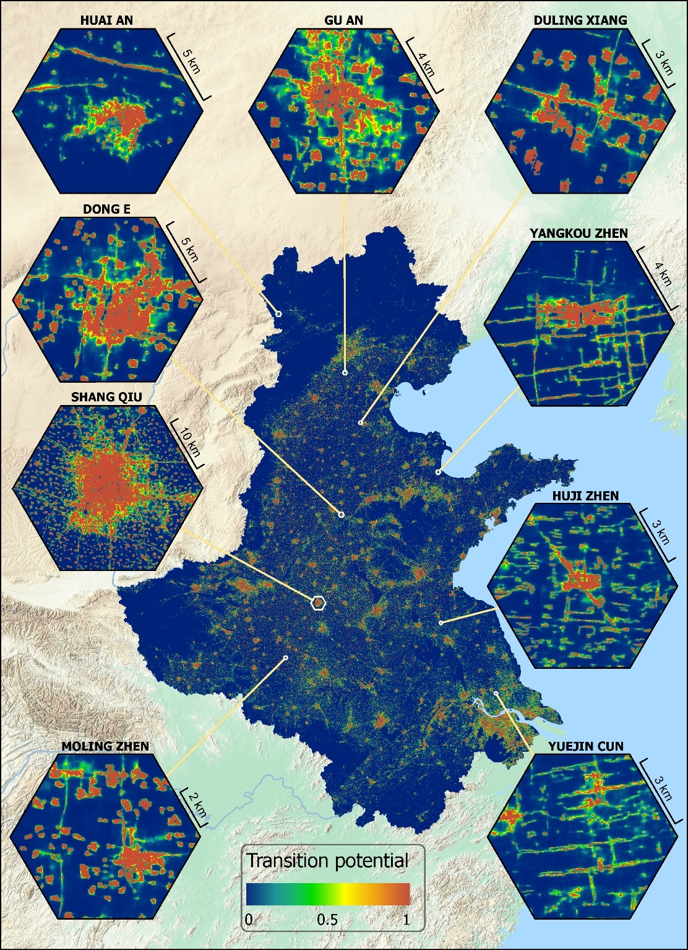

Figure 8. The transition potential map of 2005-2007 to 2017-2019.

The hard classified map (Figure 9) was created by binarizing the transition potential map. The hit and false alarm pixels were close to each other, and the linear structures were identified. For example, the correct projected urban pixels were adjacent to incorrect urban projections. Similar patterns can be found in Huai'An and Gu'An. The roads in Yang'Kou Zhen and Yue'Jin Cun were identified. Most of the missed urban projections were relatively far from the original urban areas, such as the newly developed land in Yang'Kou Zhen that was away from the old town center.

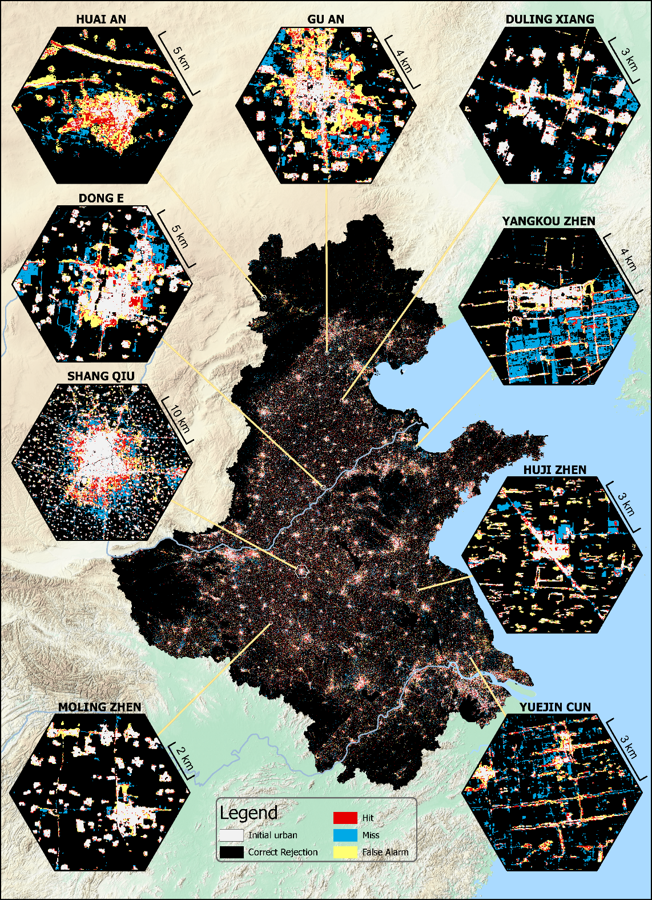

Figure 9. The hard classified map overlaid with the reference map.

## 3.3 Validation metrics

The overlay metrics of the validation maps comparing to the reference map are shown in Figure 10. The AUC the transition potential ranges from 0.70 to 0.97 with the median value of ~0.81. The median values of the OA, the hit rate, and the FoM of the hard classified map were ~0.9, ~0.33, and ~0.2, respectively.



Figure 10. The overlay metrics for the hard classified map of 2017-2019.

The landscape metrics of the hard classified map compared to the reference map are shown in Figure 11. The PN of the prediction map were systematically less than the reference map, while the LSI of both maps were close. The LPI were nearly uncorrelated between the projection and the reference map.

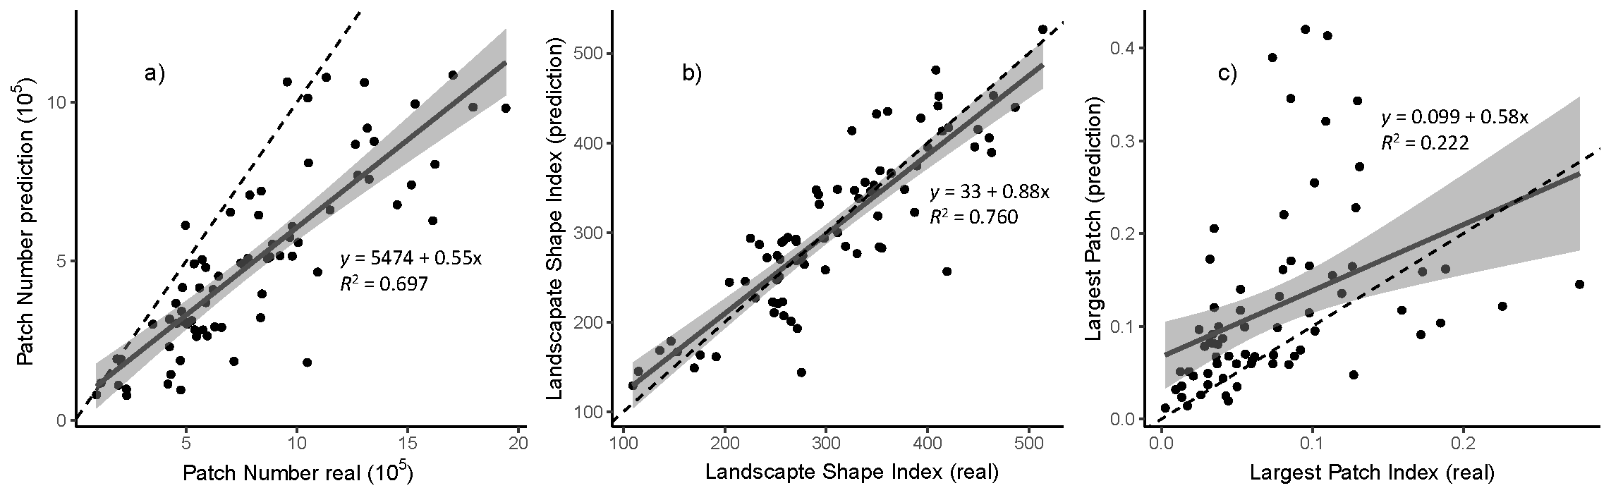

Figure 11. The landscape metrics for the hard classified map of 2017-2019. The dash line refers to y = x.

## 3.4 Prediction urban area to 2030

The historical urban areas of the North China Plain showed a strong exponential trend (Figure 12). The predicted urban area in 2030 is 218,947 km2, which is ~1.68 times to the urban area in 2017-2019.

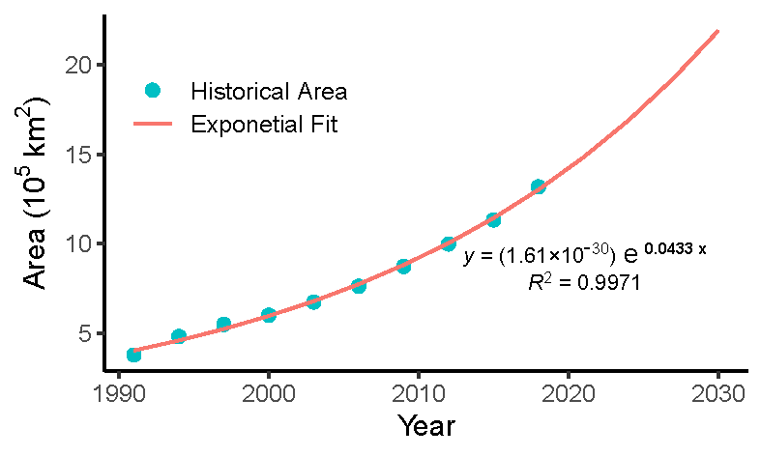

Figure 12. The exponential regression on historical urban areas.

The predicted urban map of 2030 is in Figure 13. The newly predicted urban area was proportional to the size of the urban lands it enclosed. In Shang'Qiu and Hu'Ji Zhen, the predicted urban expansion lands were larger around big cities/towns than those near smaller villages. The predicted urban area was following specified patterns rather than sprawling in every direction. For example, the predicted urban lands in Du'Ling Xiang and Yang'Kou Zhen filled the "holes" of persisting urban areas and maintained the general shape of the original urban layout. The prediction of Dong'E followed the city's elongating development trend. The predicted urban lands emerged at road-crosses in Hu'Ji Zhen and Yue'Jin Cun.

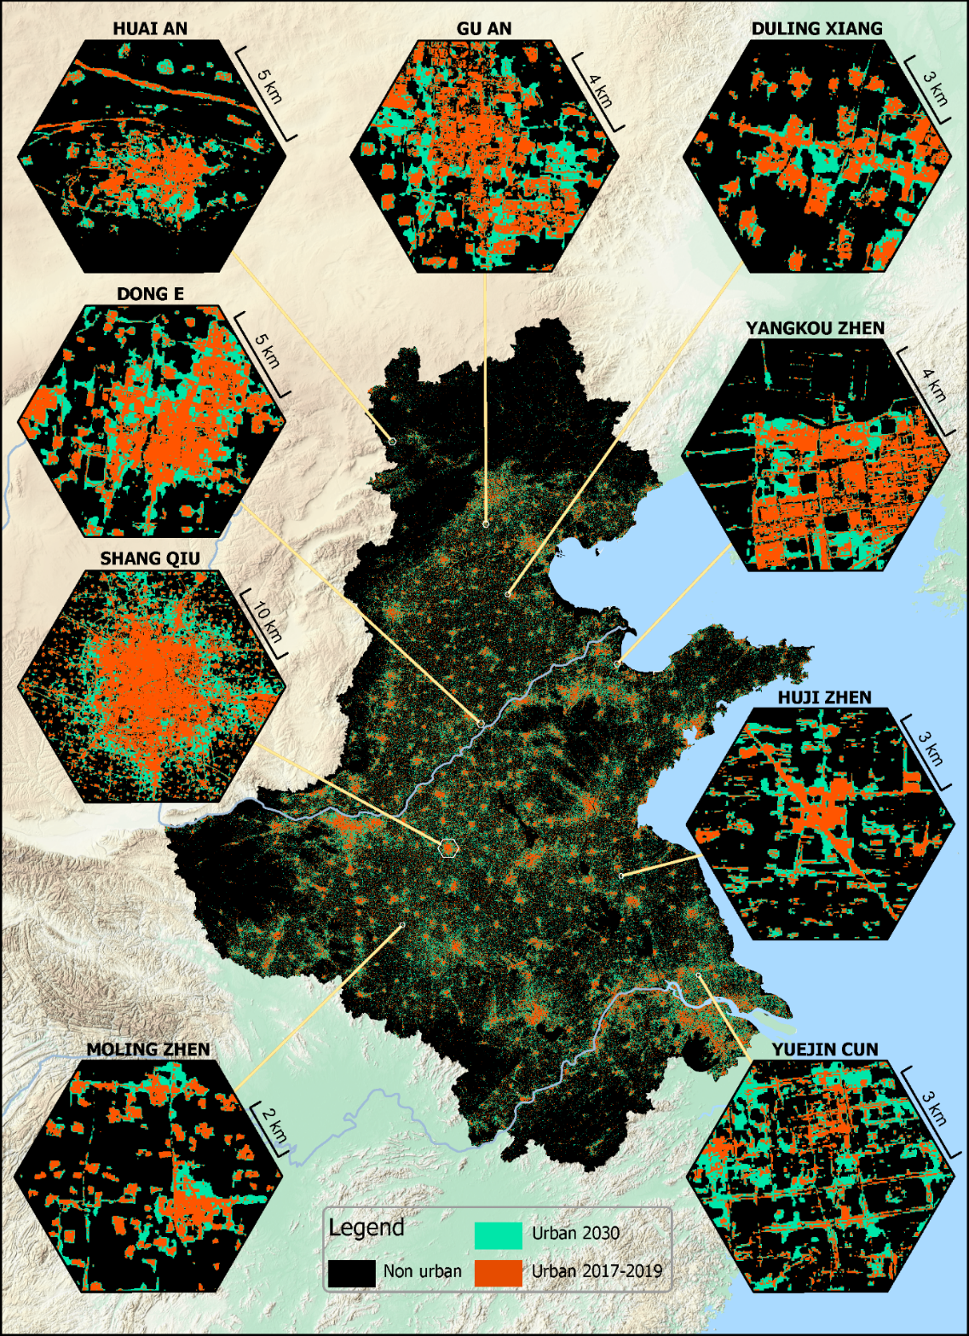

Figure 13. The simulated urban lands in 2030.

# 4. Discussion

## 4.1 Incorporating large scale spatial patterns in urban development simulation

The UNET captured large scale spatial patterns and assimilated these patterns to guide the urban development simulation at finer scales. For example, the bottleneck layer of the UNET highlighted the overview of urban layout in the target year, and this overview was gradually disintegrated into detailed shapes with finer resolution (Figure 7). The transition potential map further revealed the impact of incorporating large scope spatial features to predict future urban lands: lands near large citifies were allocated with higher transition potentials while smaller villages remained nearly unchanged (Figure 8). The other advantage of assimilating spatial features with different scales was maintaining the layout of urban land. For example, the north-south elongating development trend of Dong'E was correctly predicted by the UNET (Figure 9). The newly emerged urban lands along roads in Hu'Ji Zhen and Yue'Jin Cun were also captured in the hard classified map (Figure 9).

The large-scale spatial patterns identified by the UNET were hard to be captured by conventional CA models. A large neighborhood is required for a CA model to incorporate information at a large scale. However, the simulation performance decreased as the neighborhood reached a specific size. Wang et al. (2021a) found that the best neighborhood size to simulate urban development in Beijing is 25 × 25. Roodposhti et al. (2020) also observed that the 9 × 9 neighborhood outperformed models using other window sizes. Therefore, the unique design of the UNET is capable of digesting more extensive information than conventional CA models, enabling the urban development to be simulated with more refined spatial configurations.

## 4.2 Reducing subjectivity by automatically constructing transition rules

The UNET did not require preset parameters to simulate urban dynamics except for the learning rate and the size of training images. The transition rules were automatically generated in the form of learned weights, and the training is an unattained process that reduces subjective biases. In contrast, conventional CA models often require a complex calibration process to determine suitable parameters. For example, Feng and Tong (2020) developed a framework that integrated three algorithms and different neighborhood settings to simulate the urban growth in Shanghai, whereas an array of parameters like inertia weights, decay magnitude, spatial heterogeneity, and variable scaling were required to be specified before running the model. Many studies determine these parameters according to expert knowledge (Mustafa et al. 2017; Chen et al. 2020; Tripathy and Kumar 2019), leading to subjective biases. Other studies went through a systematic parameter selection to find the best model (Roodposhti et al. 2020; Yu et al. 2021), but this process is time-consuming and could be infeasible as the parameters increased.

## 4.3 UNET achieved similar accuracy to conventional CA models with fewer drivers

The FoM in this study ranged from 0.12 to 0.27 with the median value of 0.19, close to existing studies: the FoM of the best urban simulation map on Zhuji was 0.19 (Wang et al. 2021c), 0.21 in Beijing (Wang et al. 2021a). Some studies reported a higher FoM because the urban development was simulated at a low resolution (Pontius et al. 2008; Peng et al. 2020; Valencia et al. 2020), or the simulation was performed in a relatively smaller area (Pramanik et al. 2021). It is worth noting that this study only used urban maps, DEM and slope to simulate urban dynamics, while the conventional models took accessibility variables (i.e., distances to roads, administrative centers, and existing urban lands), suitability variables (i.e., DEM, slope, climate data) and accessories variables (population, gross domestic product, etc.) to map the urban transition potential. As a result, UNET used significantly fewer driving factors in simulating urban development but achieved similar performances to conventional CA models that were carefully calibrated.

The landscape metrics revealed that the simulation map produced by the UNET aligned well with the reference map. The LSI between the simulation and the reference was strongly correlated, and the linear regression slope is close to 1 (Figure 11). Such correlation was also embodied in the hard classified and projection maps, where the linear structure of roads and the general development trend of cities was captured in the simulation map (Figure 9, Figure 12). It is hard to compare the landscape metrics across studies because most of them only focus on one region, making the metric susceptible to the specific setting of each research. However, the general outward expansion patterns were easy to observe in many conventional urban simulations (Gao et al. 2020; Shafizadeh-Moghadam et al. 2017; Pérez-Molina et al. 2017). Therefore, the UNET had learned the inherent patterns of urban expansion compared to conventional models.

## 4.4 Limitations and prospects

This study has two limitations. The first one is not including more driving factors in the simulation. Accessibility variables such as distance to roads and railways have been proven effective in conventional urban dynamic modelling (Tripathy and Kumar 2019; Valencia et al. 2020; Ronneberger et al. 2015). However, UNET is a pattern-sensitive model. Distance factors hardly provide any useful pattern information given a 256 × 256 window. Hence, it was not used in this study. The other limitation is that UNET learned the transition rules automatically, but these rules were hidden in the three million weights. Thus, its application in planning or regulating future urban development is hampered. The following study will explore efficient ways to incorporate accessibility variables to UNET and assimilate development plans to shape the simulation results.

# 5. Conclusion

In this study, we applied the UNET to simulate urban development in 76 cities of the North China Plain. The AUC, overlay and landscape metrics were used to assess the simulation. The urban maps of 1993-1995 and 2005-2007 were used to train a validation model that created a simulated urban map of 2017-2019; this map was then evaluated against the reference map. The other model, trained on urban maps of 2005-2007 and 2017-2019, was used to project urban development to 2030.

The UNET assimilated spatial patterns of different levels that were hard to be retrieved using conventional models. The high-level spatial features were gradually extracted and then refined into detailed shapes. The large cities were enclosed with large urban lands in the simulation maps, while the smaller villages remained nearly unchanged. The roads were extended alongside the persisting road, and the general elongating development trend was capture in the simulation. However, the performances of conventional models declined as the neighborhood reached a significantly smaller size to the UNET, making proxy variables like distances to roads be employed instead. Moreover, the overlay metrics show that the simulated map from UNET achieved similar performance to the conventional models that went through a length calibration process. The landscape metrics show that the simulation of UNET was well aligned with the reference map spatially.

The UNET, using significantly fewer driving factors than conventional models, learned the inherent patterns of urban development, and automatically retrieved the transition rules in the form of model weights, contributed to the understanding of the urban dynamic mechanism and supplemented the CA models with DL technologies.

Publication bibliography

Carneiro, Murillo G.; Oliveira, Gina M. B. (2013): Synchronous cellular automata-based scheduler initialized by heuristic and modeled by a pseudo-linear neighborhood. In *Nat Comput* 12 (3), pp. 339–351. DOI: 10.1007/s11047-013-9375-8.

Chen, Shurui; Feng, Yongjiu; Tong, Xiaohua; Liu, Song; Xie, Huan; Gao, Chen; Lei, Zhenkun (2020): Modeling ESV losses caused by urban expansion using cellular automata and geographically weighted regression. In *The Science of the total environment* 712, p. 136509. DOI: 10.1016/j.scitotenv.2020.136509.

Chu, Andrea; Lin, Ying-Chen; Chiueh, Pei-Te (2017): Incorporating the effect of urbanization in measuring climate adaptive capacity. In *Land use policy* 68, pp. 28–38. DOI: 10.1016/j.landusepol.2017.07.019.

Çiçek, Özgün; Abdulkadir, Ahmed; Lienkamp, Soeren S.; Brox, Thomas; Ronneberger, Olaf (2016): 3D U-Net: Learning Dense Volumetric Segmentation from Sparse Annotation.

Clarke, Keith C.; Johnson, J. Michael (2020): Calibrating SLEUTH with big data: Projecting California's land use to 2100. In *Computers, Environment and Urban Systems* 83, p. 101525. DOI: 10.1016/j.compenvurbsys.2020.101525.

Feng, Yongjiu; Tong, Xiaohua (2020): A new cellular automata framework of urban growth modeling by incorporating statistical and heuristic methods. In *International Journal of Geographical Information Science* 34 (1), pp. 74–97. DOI: 10.1080/13658816.2019.1648813.

Gantumur, Byambakhuu; Wu, Falin; Vandansambuu, Battsengel; Tsegmid, Bazarkhand; Dalaibaatar, Enkhjargal; Zhao, Yan (2020): Spatiotemporal dynamics of urban expansion and its simulation using CA-ANN model in Ulaanbaatar, Mongolia. In *Geocarto International*, pp. 1–16. DOI: 10.1080/10106049.2020.1723714.

Gao, Chen; Feng, Yongjiu; Tong, Xiaohua; Lei, Zhenkun; Chen, Shurui; Zhai, Shuting (2020): Modeling urban growth using spatially heterogeneous cellular automata models: Comparison of spatial lag, spatial error and GWR. In *Computers, Environment and Urban Systems* 81, p. 101459. DOI: 10.1016/j.compenvurbsys.2020.101459.

Goodchild, Michael F. (2004): The Validity and Usefulness of Laws in Geographic Information Science and Geography. In *Annals of the Association of American Geographers* 94 (2), pp. 300–303. DOI: 10.1111/j.1467-8306.2004.09402008.x.

Gorelick, Noel; Hancher, Matt; Dixon, Mike; Ilyushchenko, Simon; Thau, David; Moore, Rebecca (2017): Google Earth Engine: Planetary-scale geospatial analysis for everyone. In *Remote Sens Environ* 202, pp. 18–27. DOI: 10.1016/j.rse.2017.06.031.

Hubel, David H.; Torsten N. Wiesel (1962): Receptive fields, binocular interaction and functional architecture in the cat's visual cortex. In *The Journal of physiology* 160, pp. 106–154. DOI: 10.1113/jphysiol.1962.sp006837.

Iglovikov, Vladimir; Shvets, Alexey (2018): TernausNet: U-Net with VGG11 Encoder Pre-Trained on ImageNet for Image Segmentation.

Ji, Shunping; Wei, Shiqing; Lu, Meng (2019): A scale robust convolutional neural network for automatic building extraction from aerial and satellite imagery. In *International Journal of Remote Sensing* 40 (9), pp. 3308–3322. DOI: 10.1080/01431161.2018.1528024.

Kalnay, Eugenia; Cai, Ming (2003): Impact of urbanization and land-use change on climate. In *Nature* 423 (6939), pp. 528–531. DOI: 10.1038/nature01675.

Krizhevsky, Alex; Sutskever, Ilya; Hinton, Geoffrey E. (2017): ImageNet classification with deep convolutional neural networks. In *Commun. ACM* 60 (6), pp. 84–90. DOI: 10.1145/3065386.

Li, Xuecao; Gong, Peng; Le Yu; Hu, Tengyun (2017): A segment derived patch-based logistic cellular automata for urban growth modeling with heuristic rules. In *Computers, Environment and Urban Systems* 65, pp. 140–149. DOI: 10.1016/j.compenvurbsys.2017.06.001.

Lin, Jingyu; Huang, Jinliang; Prell, Christina; Bryan, Brett A. (2021): Changes in supply and demand mediate the effects of land-use change on freshwater ecosystem services flows. In *The Science of the total environment* 763, p. 143012. DOI: 10.1016/j.scitotenv.2020.143012.

Long, Jonathan; Shelhamer, Evan; Darrell, Trevor (2015): Fully convolutional networks for semantic segmentation, pp. 3431–3440. DOI: 10.1109/CVPR.2015.7298965.

Mansour, Shawky; Al-Belushi, Mohammed; Al-Awadhi, Talal (2020): Monitoring land use and land cover changes in the mountainous cities of Oman using GIS and CA-Markov modelling techniques. In *Land use policy* 91, p. 104414. DOI: 10.1016/j.landusepol.2019.104414.

Mustafa, Ahmed; Cools, Mario; Saadi, Ismaïl; Teller, Jacques (2017): Coupling agent-based, cellular automata and logistic regression into a hybrid urban expansion model (HUEM). In *Land use policy* 69, pp. 529–540. DOI: 10.1016/j.landusepol.2017.10.009.

Mustafa, Ahmed; Heppenstall, Alison; Omrani, Hichem; Saadi, Ismaïl; Cools, Mario; Teller, Jacques (2018): Modelling built-up expansion and densification with multinomial logistic regression, cellular automata and genetic algorithm. In *Computers, Environment and Urban Systems* 67, pp. 147–156. DOI: 10.1016/j.compenvurbsys.2017.09.009.

National Bureau of Statistics of China (2019a): Announcement of the 2019 grain output. Beijing, China. Available online at http://www.gov.cn/xinwen/2019-12/07/content_5459250.htm, checked on 12/20/2020.

National Bureau of Statistics of China (2019b): China Statistical Yearbook. Beijing, China: China Statistics Press, checked on 11/6/2020.

Nezla, N. A.; Mithun Haridas, T. P.; Supriya, M. H.: Semantic Segmentation of Underwater Images using UNet architecture based Deep Convolutional Encoder Decoder Model, pp. 28–33. DOI: 10.1109/ICACCS51430.2021.9441804.

Peng, Kaifeng; Jiang, Weiguo; Deng, Yue; Liu, Yinghui; Wu, Zhifeng; Chen, Zheng (2020): Simulating wetland changes under different scenarios based on integrating the random forest and CLUE-S models: A case study of Wuhan Urban Agglomeration. In *Ecological Indicators* 117, p. 106671. DOI: 10.1016/j.ecolind.2020.106671.

Pérez-Molina, Eduardo; Sliuzas, Richard; Flacke, Johannes; Jetten, Victor (2017): Developing a cellular automata model of urban growth to inform spatial policy for flood mitigation: A case study in Kampala, Uganda. In *Computers, Environment and Urban Systems* 65, pp. 53–65. DOI: 10.1016/j.compenvurbsys.2017.04.013.

Pontius, Robert Gilmore; Boersma, Wideke; Castella, Jean-Christophe; Clarke, Keith; Nijs, Ton de; Dietzel, Charles et al. (2008): Comparing the input, output, and validation maps for several models of land change. In *Ann Reg Sci* 42 (1), pp. 11–37. DOI: 10.1007/s00168-007-0138-2.

Pramanik, Suvamoy; Butsch, Carsten; Punia, Milap (2021): Post-liberal urban dynamics in India – The case of Gurugram, the ‘Millennium City’. In *Remote Sensing Applications: Society and Environment* 22, p. 100504. DOI: 10.1016/j.rsase.2021.100504.

Prayitno, Gunawan (2020): Land-use prediction in Pandaan District pasuruan regency. In *GEOMATE* 18 (65). DOI: 10.21660/2020.65.41738.

Qian, Yuehui; Xing, Weiran; Guan, Xuefeng; Yang, Tingting; Wu, Huayi (2020): Coupling cellular automata with area partitioning and spatiotemporal convolution for dynamic land use change simulation. In *The Science of the total environment* 722, p. 137738. DOI: 10.1016/j.scitotenv.2020.137738.

Qiu, Tong; Song, Conghe; Zhang, Yulong; Liu, Hongsheng; Vose, James M. (2020): Urbanization and climate change jointly shift land surface phenology in the northern mid-latitude large cities. In *Remote Sensing of Environment* 236, p. 111477. DOI: 10.1016/j.rse.2019.111477.

Ronneberger, Olaf; Fischer, Philipp; Brox, Thomas (2015): U-Net: Convolutional Networks for Biomedical Image Segmentation 9351, pp. 234–241. DOI: 10.1007/978-3-319-24574-4_28.

Roodposhti, Majid Shadman; Hewitt, Richard J.; Bryan, Brett A. (2020): Towards automatic calibration of neighbourhood influence in cellular automata land-use models. In *Computers, Environment and Urban Systems* 79, p. 101416. DOI: 10.1016/j.compenvurbsys.2019.101416.

Ruiz Hernandez, Ivan Elias; Shi, Wenzhong (2018): A Random Forests classification method for urban land-use mapping integrating spatial metrics and texture analysis. In *International Journal of Remote Sensing* 39 (4), pp. 1175–1198. DOI: 10.1080/01431161.2017.1395968.

Shafizadeh-Moghadam, Hossein; Asghari, Ali; Tayyebi, Amin; Taleai, Mohammad (2017): Coupling machine learning, tree-based and statistical models with cellular automata to simulate urban growth. In *Computers, Environment and Urban Systems* 64, pp. 297–308. DOI: 10.1016/j.compenvurbsys.2017.04.002.

Singh, Manmeet; Kumar, Bipin; Rao, Suryachandra; Gill, Sukhpal Singh; Chattopadhyay, Rajib; Nanjundiah, Ravi S.; Niyogi, Dev: Deep learning for improved global precipitation in numerical weather prediction systems.

Tobler, W. R. (1970): A Computer Movie Simulating Urban Growth in the Detroit Region. In *Economic Geography* 46, p. 234. DOI: 10.2307/143141.

Tong, Xiaohua; Feng, Yongjiu (2020): A review of assessment methods for cellular automata models of land-use change and urban growth. In *International Journal of Geographical Information Science* 34 (5), pp. 866–898. DOI: 10.1080/13658816.2019.1684499.

Tripathy, Pratyush; Kumar, Amit (2019): Monitoring and modelling spatio-temporal urban growth of Delhi using Cellular Automata and geoinformatics. In *Cities* 90, pp. 52–63. DOI: 10.1016/j.cities.2019.01.021.

Tzaninis, Yannis; Mandler, Tait; Kaika, Maria; Keil, Roger (2021): Moving urban political ecology beyond the 'urbanization of nature'. In *Progress in human geography* 45 (2), pp. 229–252. DOI: 10.1177/0309132520903350.

Valencia, Victor H.; Levin, Gregor; Hansen, Henning Sten (2020): Modelling the spatial extent of urban growth using a cellular automata-based model: a case study for Quito, Ecuador. In *Geografisk Tidsskrift-Danish Journal of Geography* 120 (2), pp. 156–173. DOI: 10.1080/00167223.2020.1823867.

Wang, Haijun; Guo, Jiaqi; Zhang, Bin; Zeng, Haoran (2021a): Simulating urban land growth by incorporating historical information into a cellular automata model. In *Landscape and Urban Planning* 214, p. 104168. DOI: 10.1016/j.landurbplan.2021.104168.

Wang, Jinzhu; Hadjikakou, Michalis; Bryan, Brett A. (2021b): Consistent, accurate, high resolution, long time-series mapping of built-up land in the North China Plain. In *GIScience & Remote Sensing*, pp. 1–17. DOI: 10.1080/15481603.2021.1948275.

Wang, Rong; Feng, Yongjiu; Wei, Yongliang; Tong, Xiaohua; Zhai, Shuting; Zhou, Yilun; Wu, Peiqi (2021c): A comparison of proximity and accessibility drivers in simulating dynamic urban growth. In *Transactions in GIS* 25 (2), pp. 923–947. DOI: 10.1111/tgis.12707.

Xia, Chang; Zhang, Bin (2021): Exploring the effects of partitioned transition rules upon urban growth simulation in a megacity region: a comparative study of cellular automata-based models in the Greater Wuhan Area. In *GIScience & Remote Sensing*, pp. 1–24. DOI: 10.1080/15481603.2021.1933714.

Xing, Weiran; Qian, Yuehui; Guan, Xuefeng; Yang, Tingting; Wu, Huayi (2020): A novel cellular automata model integrated with deep learning for dynamic spatio-temporal land use change simulation. In *Computers & Geosciences* 137, p. 104430. DOI: 10.1016/j.cageo.2020.104430.

Yao, Wei; Zeng, Zhigang; Lian, Cheng; Tang, Huiming (2018): Pixel-wise regression using U-Net and its application on pansharpening. In *Neurocomputing* 312, pp. 364–371. DOI: 10.1016/j.neucom.2018.05.103.

Yu, Jingyan; Hagen-Zanker, Alex; Santitissadeekorn, Naratip; Hughes, Susan (2021): Calibration of cellular automata urban growth models from urban genesis onwards - a novel application of Markov chain Monte Carlo approximate Bayesian computation. In *Computers, Environment and Urban Systems* 90, p. 101689. DOI: 10.1016/j.compenvurbsys.2021.101689.

Yue, Huanbi; He, Chunyang; Huang, Qingxu; Yin, Dan; Bryan, Brett A. (2020): Stronger policy required to substantially reduce deaths from PM2.5 pollution in China. In *Nature communications* 11 (1), p. 1462. DOI: 10.1038/s41467-020-15319-4.

Zhai, Yaqian; Yao, Yao; Guan, Qingfeng; Liang, Xun; Li, Xia; Pan, Yongting et al. (2020): Simulating urban land use change by integrating a convolutional neural network with vector-based cellular automata. In *International Journal of Geographical Information Science* 34 (7), pp. 1475–1499. DOI: 10.1080/13658816.2020.1711915.